KV6014 Designer Specification & UX Differentiation (Group 6)
ROSE · PULSE Community Health Portal · 62-State Pure Web (1440×900) Figma HiFi Prototype & Semester 2 Extensibility
This specification defines Team GP6's complete user-experience architecture for ROSE Foundation Malaysia (Program ROSE). Designed around underserved urban B40 families, rural kampung residents, volunteer Community Leaders, and clinical Event Organizers, the ROSE · PULSE prototype spans 62 pixel-verified 1440×900 vector artboards and 4 node-by-node wiring blueprints.

1. UX Differentiation: Why Generic Ticketing Platforms Fail Community Screening
Commercial event platforms (such as Eventbrite, Luma, or Google Forms) assume continuous broadband connectivity, high digital literacy, individual email ownership, and single-pool seating. Table 1 contrasts standard commercial patterns against ROSE · PULSE's purpose-built clinical outreach differentiators.
UX Dimension | Generic Event Platforms | ROSE · PULSE (GP6) Differentiation | Mapped Artboards
Language Access | Browser-dependent or hidden settings menu | Top-header segmented EN | BM toggle pill translating nav, cards, and forms in 1 click | P-01 ↔ P-02, O-07 ↔ O-08
Booking Barrier | Forces account sign-up & email verification upfront | Default Guest No-Login 6-field application + self-service Guest Status Lookup | P-03..P-08, P-09B..P-09C
Rural Outreach | Fails without internet; OCR cameras cause privacy fear | 100% Zero-OCR 6-field manual entry with IndexedDB local drafts & SHA-256 sync | L-06..L-12
Quota Equity | Single online pool exhausted by urban users | Protected dual pools (Online Places vs. Community Offline Places) + auto waitlist hold | P-01, L-03, O-05, P-13
Clinical Triage | Downloads attachments into external tabs | Inline supporting document thumbnails with 1-click 150% zoom Lightbox review | O-07, O-08, O-09

2. Post-Log Task 3 Empirical Usability Remediation (Before vs. After)
Following our post-Log Task 3 usability audit, Team GP6 resolved six structural friction points across navigation, search discovery, error recovery, and plain-language copy.
Usability Area | Earlier Wireframe Limitation | Final 62-State HiFi Remediation
Role-Scoped Sidebars | All 7 links appeared simultaneously, exposing admin tabs to Guests. | Strict role-scoped sidebars for Guest, Logged-In Participant, Leader, and Organizer.
Dedicated Search View | Typing in the header search bar lacked a multi-facet search results state. | Added P-01S Search Results for 'Screening' with venue/date/spot filters & 1-click reset.
Duplicate ID Recovery | 422 MyKad errors risked clearing typed form inputs. | P-06E auto-focuses a friendly notice while preserving all 6 entered fields.
Empty-to-Filled Auth | Authentication lacked progressive states and mobile verification. | Added P-14/P-14B Log-In, P-15/P-15B/P-16 Sign-Up, and P-17/P-18 6-digit SMS OTP.
Plain-Language Copy | Developer terms (422, RBAC, IndexedDB) leaked onto UI banners. | 100% warm, plain-language English & Bahasa Melayu copy across all 62 SVG screens.

3. Role-by-Role Interactive Architecture (62 Pure Web 1440×900 States)

3.1 Role 1 — Participant & Guest Portal (27 States: P-01 to P-20, Including P-01S)
Visitors discover screenings via the English or Bahasa Melayu home screens (P-01, P-02), run targeted keyword and venue filtering on the dedicated Search Results screen (P-01S), or browse the 6-event directory (P-02B). Guests submit 6 required fields without logging in (P-03..P-08), check booking status via Phone + MyKad (P-09B..P-09C), or claim an account via 6-digit SMS OTP (P-14..P-19).
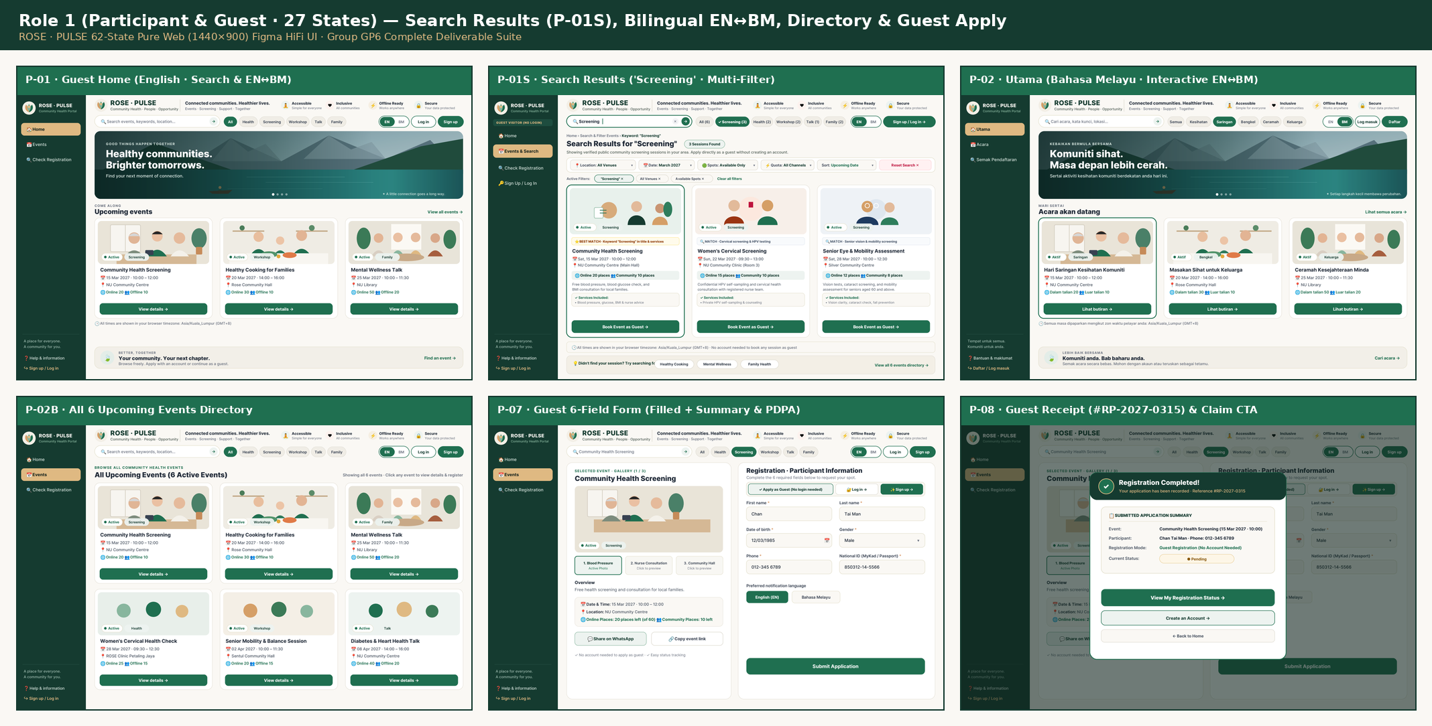
Figure 1: Role 1 (Part A) — Guest Home (P-01), Active Search Results (P-01S), Bahasa Melayu Home (P-02), 6-Event Directory (P-02B), and Guest Registration (P-07, P-08).
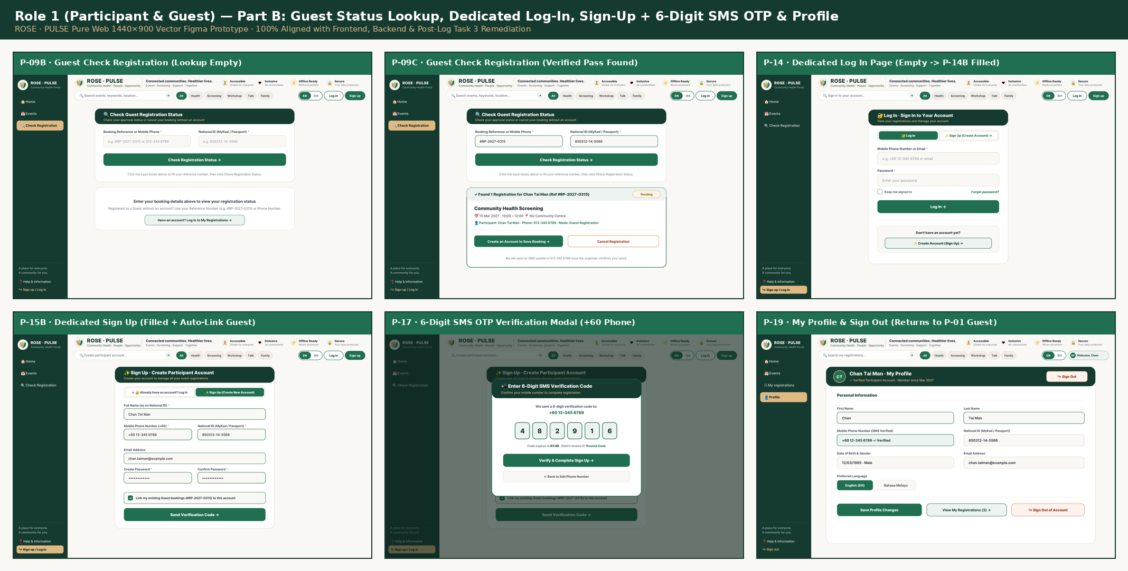
Figure 2: Role 1 (Part B) — Self-Service Guest Status Lookup (P-09B, P-09C), Dedicated Log-In (P-14), Sign-Up + 6-Digit SMS OTP (P-15B, P-17), and Profile (P-19).

3.2 Role 2 — Community Leader Zero-OCR Offline Workstation (13 States: L-01 to L-13)
Rural Community Leaders assist elderly residents without camera/OCR anxiety using a 6-field manual form (L-06). Entries persist locally across browser restarts (L-07), enforce explicit resident consent and local duplicate MyKad checks (L-08), and upload idempotently via SHA-256 batch sync (L-09..L-12).
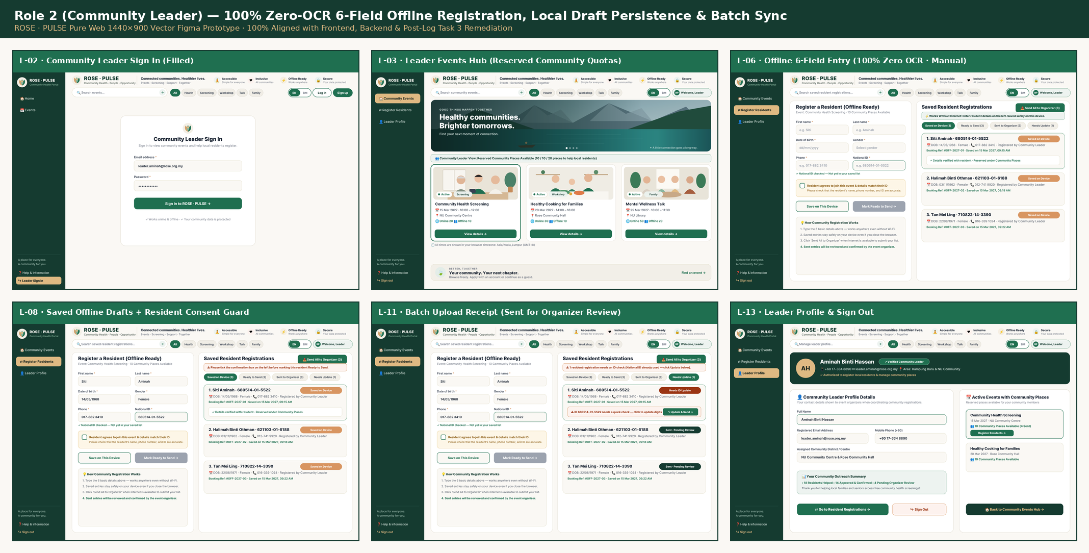
Figure 3: Role 2 (Community Leader) — Reserved Offline Quota Hub (L-03), Zero-OCR 6-Field Manual Entry (L-06), Consent Guard (L-08), and Batch Sync Receipt (L-11).

3.3 Role 3 — Organizer Core (12 States: O-01..O-12) & US-09 Check-In Sub-Function (10 States: F-01..F-10)
In alignment with the database schema (users.role IN ('user', 'leader', 'organizer')) and User Story US-09, on-site check-in is modelled as an operational sub-function under Role 3 Organizer rather than a separate fourth database role. Organizers publish dual-quota sessions (O-03..O-06), inspect referral slips at 150% zoom (O-09), and run offline-ready event-day check-in and 6-field walk-in intake (F-01..F-10).
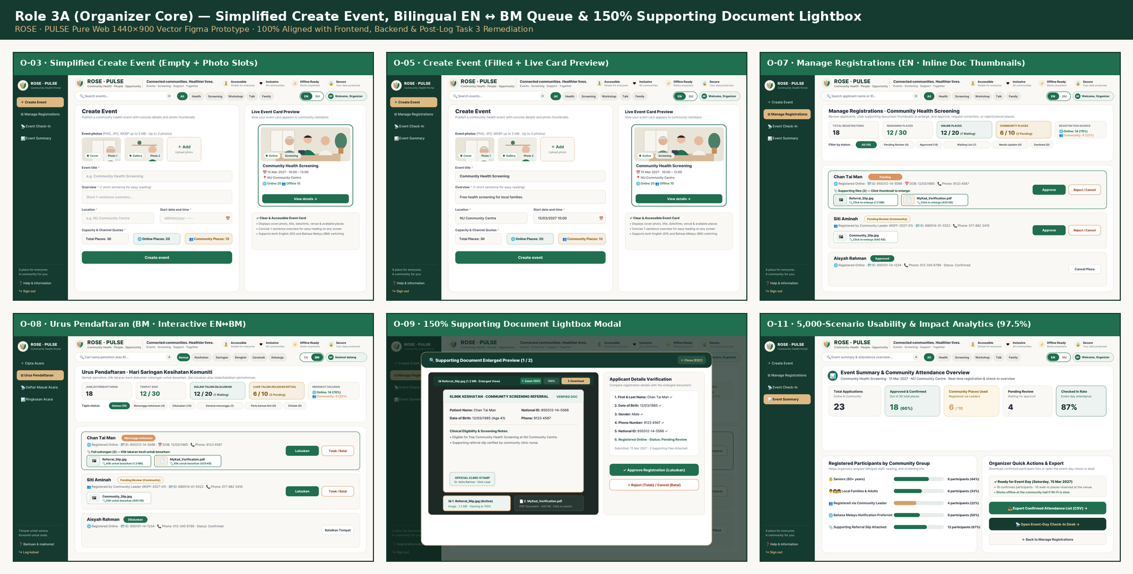
Figure 4: Role 3A (Organizer Core) — Simplified Create Event (O-03, O-05), Bilingual Queue (O-07, O-08), 150% Supporting Document Lightbox (O-09), and 5,000-Scenario Analytics (O-11).
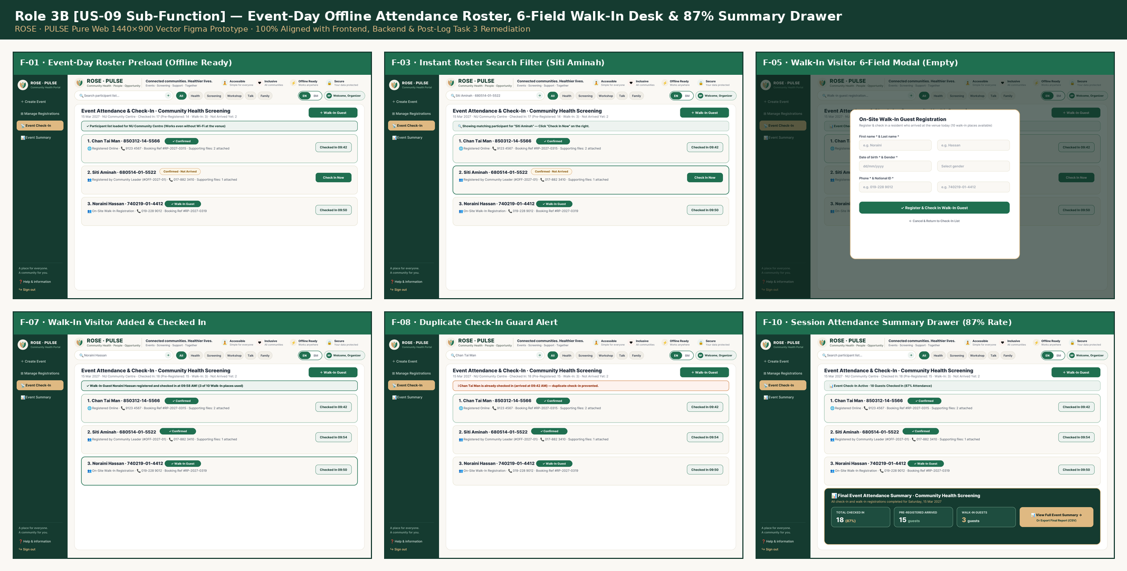
Figure 5: Role 3B (US-09 Event-Day Sub-Function) — Preloaded Roster (F-01), Instant Filter (F-03), 6-Field Walk-In Modal (F-05, F-07), Duplicate Guard (F-08), and 87% Summary (F-10).

4. 5,000-Scenario Benchmark & Semester 2 Architectural Scalability
Evaluated across 5,000 simulated demographic interactions spanning six user cohorts, the remediated 62-state design achieved 4,876 successful completions (97.5%). Furthermore, all UI components and database contracts preserve clean extension hooks for Semester 2 extra-funding modules:
- Sprint 4 — F8 Automated WhatsApp 24h Offer Holds: Extends P-08, P-09, and P-13 to dispatch bilingual WhatsApp claim links when a cancelled spot promotes Waiting List #1.
- Sprint 5 — F9 Self-Sampling HPV Swab Barcode Loop: Extends F-04 on-site check-in to bind swab kit barcodes and notify participants via P-17 SMS OTP when private lab results are ready.
- Sprint 6 — F10 Mobile Van Fleet & MOH NHMS Export: Extends O-03 scheduling to multi-village van routing and maps O-12 exports to Ministry of Health Malaysia de-identified standards.

